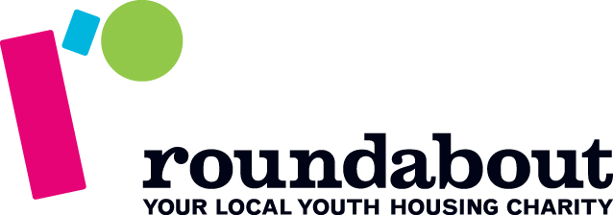
Fundraising Agreement Form
Registered Charity No. 1061313
Please state if you are fundraising in a personal or business capacity and complete the relevant details below:
Personal: Business: Community/Church Group:

Your Name:
Date of Birth:
(dd/mm/yyyy)
Company/Community Group/Church Name:
(if appropriate)
Address: |  | Please let us know if you would like to receive charity news by:  post email
Postcode: |  | Telephone:
Email:
Twitter & Facebook Details: | Don’t forget to use #homeless  & #EndYouthHomelessness

Contact details

Name of Event/  Description of  Activity: |  |  | Date of Event: | DD/MM/YYYY
Are you fundraising  as part of a group? | YES NO
If Yes, please provide: | Name of group:
Names of other participants:
(continue on another sheet if necessary)
Just Giving/BT MyDonate page name:
(if appropriate)
Event details

Fundraising Target:
(How much are you aiming to raise?)
Why did you choose to fundraise for Roundabout?
How did you find out about Roundabout?

Venue Name:
Venue
Manager’s Name:
Venue Manager’s number:
Venue Manager’s Signature:
Venue details

Fundraising materials
Sponsor  forms |  | Balloons
Collection Tins  (Pick up from office only) |  | Collection Buckets  (Pick up from office only)
Leaflets
T-shirts  (Max Total of 4; additional £5 each) | S
 | M
 | L
 | XL

.

I give permission for Roundabout to use any photographs I may send, for use in their literature and promotional materials, which may include their website and social media channels. (Please tick)
I agree that all the proceeds from the above event/fundraising activity will go to Roundabout to support our work with vulnerable young people aged 16-24 who are homeless or at risk of homelessness.
Signature:
Date: / /
Please note that if you are under the age of 16, we will require a signature from a parent/guardian for you to participate in any fundraising activity for Roundabout.

Parent/Guardian Signature:
Date: / /

Please complete this form and return to :Roundabout, The Circle, 4th Floor, Rockingham Lane, Sheffield, S1 4FW or e-mail to fundraising@roundaboutltd.org
If you have a query about this form, please call the Fundraising Team on 0114 253 6753.

