TITLE OF ROLE: Photography Volunteer
PURPOSE OF ROLE: To help us capture every aspect of the Yorkshire Chocolate Festival, increase fundraising potential and advertising opportunities for the future.
MAIN TASKS/ ACTIVITIES OF THIS ROLE:
- Taking photos of all aspects of the Yorkshire Chocolate Festival including workshops, stall holders and the general public
- Selecting and editing the best photos and sending them on to the Event Organiser to be used across social media and promotion in the local press

SKILLS, EXPERIENCE AND QUALITIES REQUIRED
 | WHAT WE WOULD LIKE YOU TO HAVE WHEN YOU APPLY
Skills and Experience | - You will need to have your own equipment or be able to borrow it  - Be comfortable using a camera  - If you are able to edit your photos that is a bonus.
Knowledge and understanding | - Awareness of media consent  - Understanding of the event so that you are able to capture the right content
Qualities | - Creative  - Outgoing and confident – being able to approach stall holders and the public  - Organised
Time Commitment | The event will be on Sunday 24th October, 10am - 4pm, at Kelham Island Museum.  We will need help throughout the day from 9:30am until 4:30pm, but you do not need to volunteer for the whole day, just a few hours to suit you!
Training Required | We will provide a full brief prior to the event and you will be supported in your volunteering role on the day. All volunteers will be provided with a snack pack.
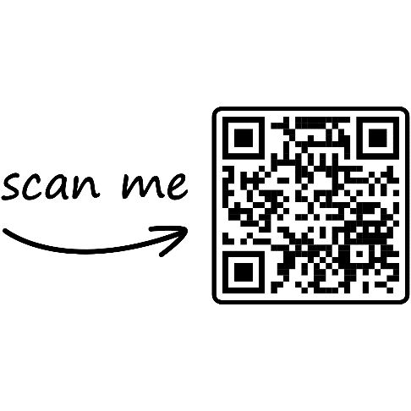
If you are interested in applying to this role, please contact fundraising@roundaboutltd.org for an application form or scan the QR code to complete our online registration from.
Thank you.

